ASQA Assignment 2

searchRings

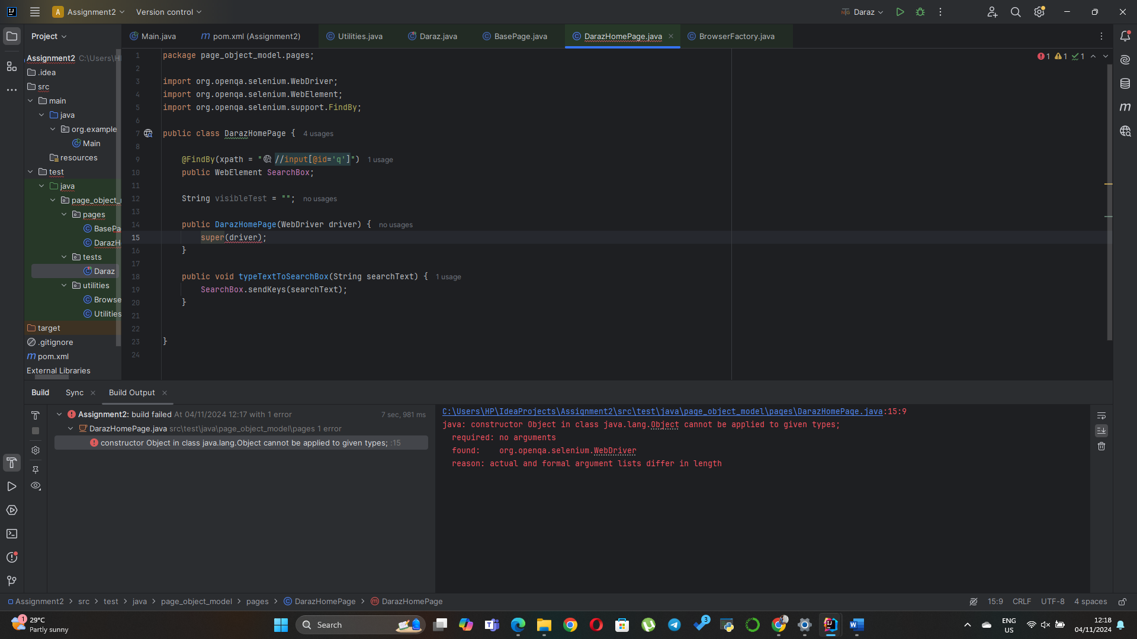

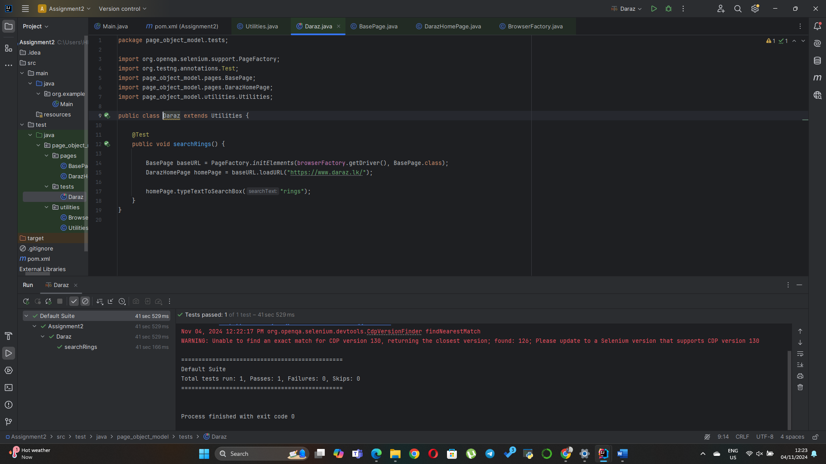

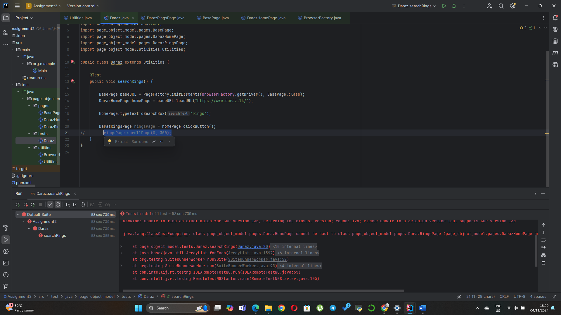

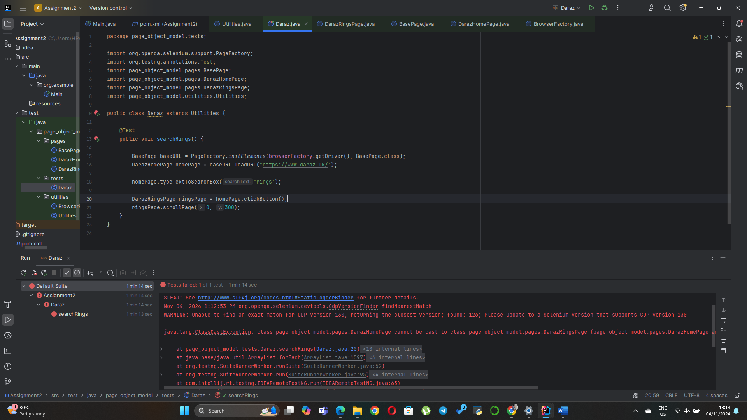

searchPhones

SearchWatches

